Q1. Prompt for amount, interest rate and no. of years and calculate simple interest.
A1. 1.html
<!DOCTYPE html>
<html>
<head>
<title>SI Calculator</title>
<body style="text-align: center;">
<h2>Simple Interest Calculator</h2>
<button onclick="submitDetails()">Click here to calculate</button>
<p id = "amt"></p>
<p id = "interest-rate"></p>
<p id = "no-of-years"></p>
<p id = "si"></p>

<script src = '1.js'></script>
</body>
</html>

1.js
function submitDetails(){
var amt = prompt('Enter amount: ');
if (amt != null) {
document.getElementById("amt").innerHTML = "Amount: " + amt;
}

var ir = prompt('Enter interest rate: ');
if (ir != null) {
document.getElementById('interest-rate').innerHTML = "Interest Rate: " + ir;
}

var noy = prompt('Enter number of years: ');
if (noy != null) {
document.getElementById('no-of-years').innerHTML = "Number of years: " + noy;
}

var si = amt * noy * ir / 100;
document.getElementById('si').innerHTML = "<br><br> Simple Interest: " + si;
}
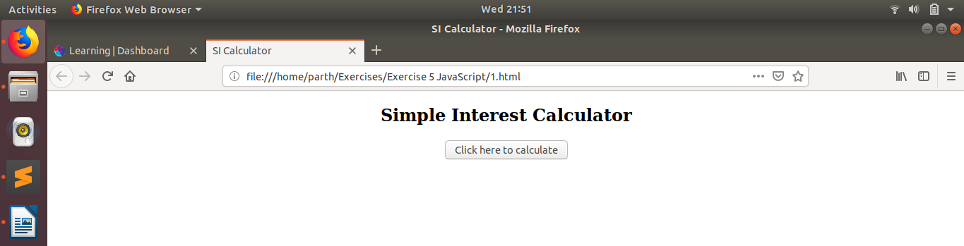

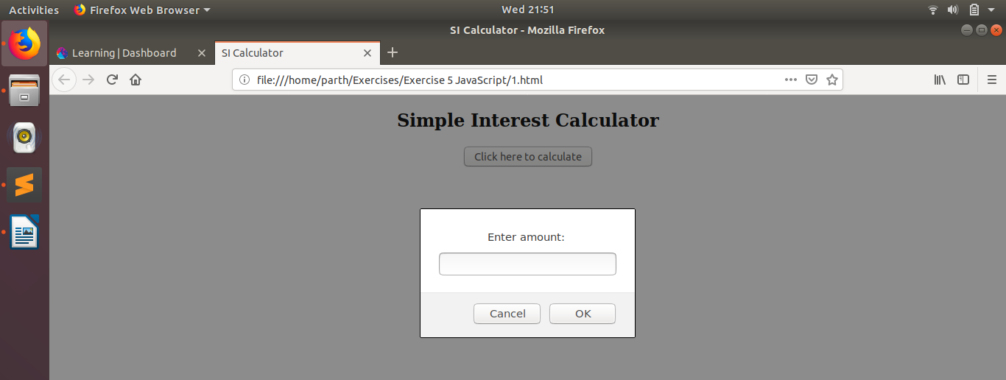

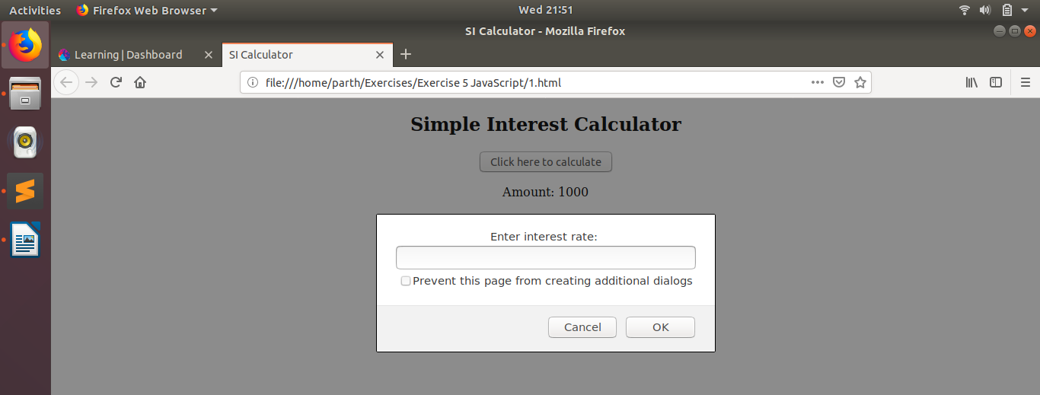
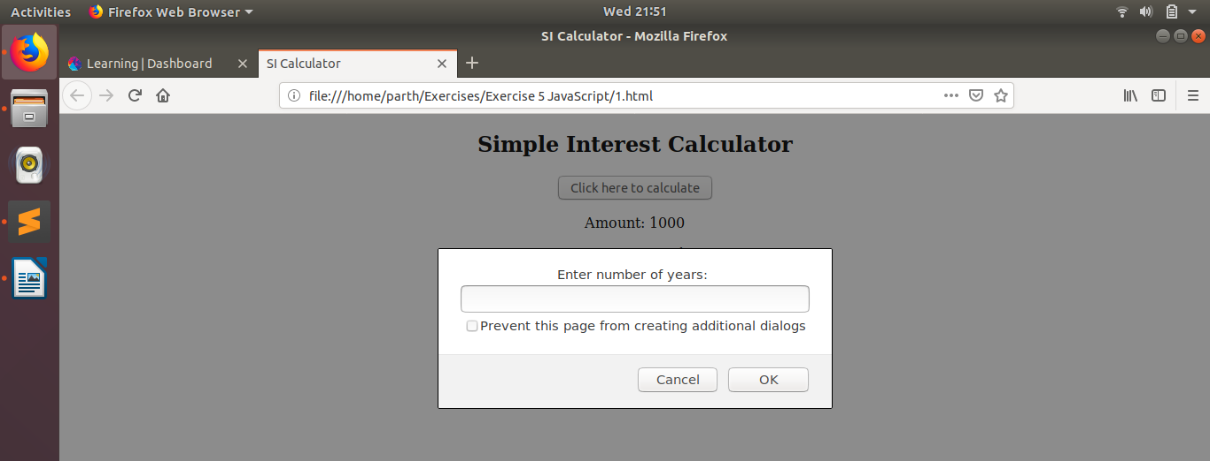
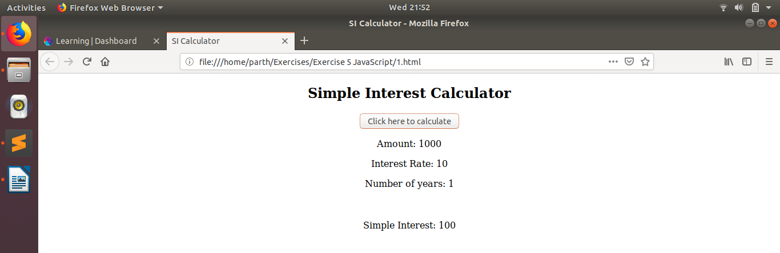

Q2. is palindrome string
A2. 2.html
<!DOCTYPE html>
<html>
<head>
<title>Check palindrome</title>
</head>

<body style="text-align: center;">

<h2>Palindrome Check</h2>
<button onclick="checkPalin()">Enter string</button>
<p id = "response"></p>

<script src = '2.js'></script>
</body>
</html>

2.js
function checkPalin(){
var str = prompt('Enter string to be checked: ');
document.getElementById('response').innerHTML = 'String entered:<br>' + str + "<br><br>";

if (str == str.split("").reverse().join("")){
document.getElementById('response').insertAdjacentHTML('beforeend', "<br>String IS A palindrome");
}

else{
document.getElementById('response').insertAdjacentHTML('beforeend', "<br>String is NOT a palindrome");
}
}

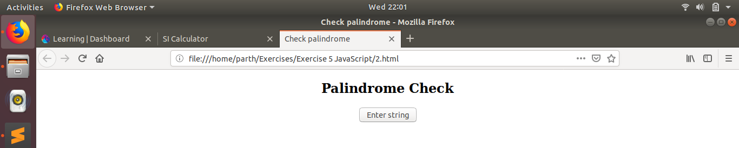
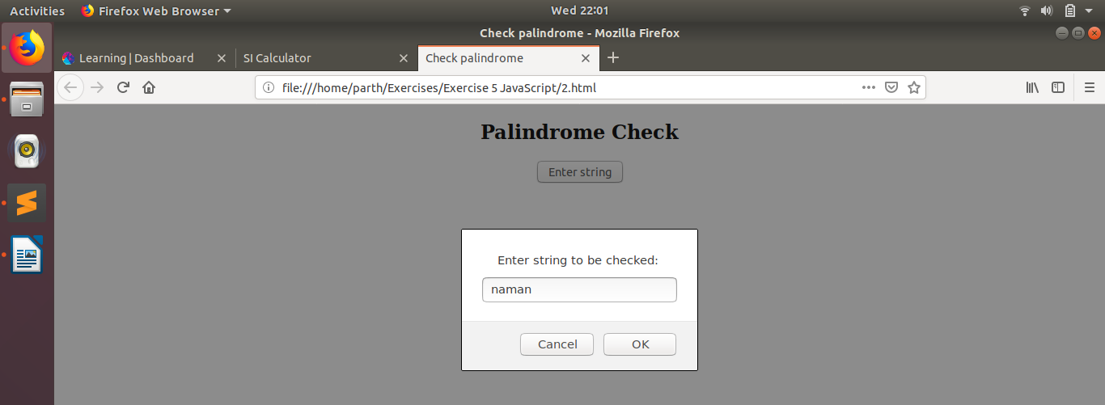
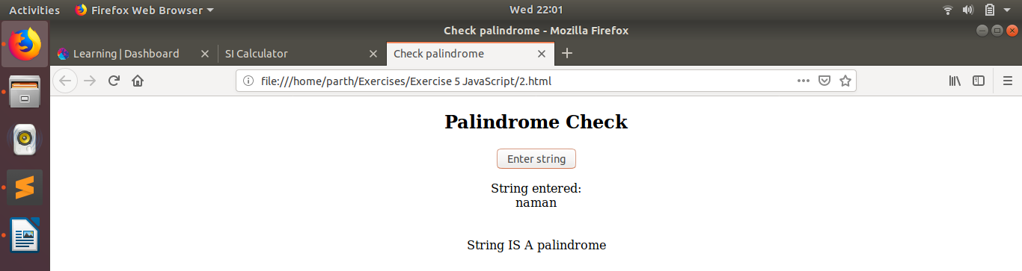

Q3. Area of circle
A3. 3.html
<!DOCTYPE html>
<html>
<head>
<title>Circle</title>
</head>

<body style="text-align: center; align-content: center;">

<h2>Create a circle</h2>
<button onclick="createCircle()">Enter radius</button>
<p id = "response"></p>
<div id = 'circle'></div>

<script src = '3.js'></script>
</body>
</html>

3.js
function createCircle(){
var r = prompt('Enter radius of circle: ');
document.getElementById('response').innerHTML = 'Radius entered:<br>' + r + "<br><br>Area of circle: " + Math.PI * r * r;
document.getElementById('circle').setAttribute('style', "width: " + (2 * r).toString() + "px; " + "height: " + (2 * r).toString() + "px; " + "border-radius:" + r.toString() + "px;" + "background: red;"
+ "display: inline-block");
}

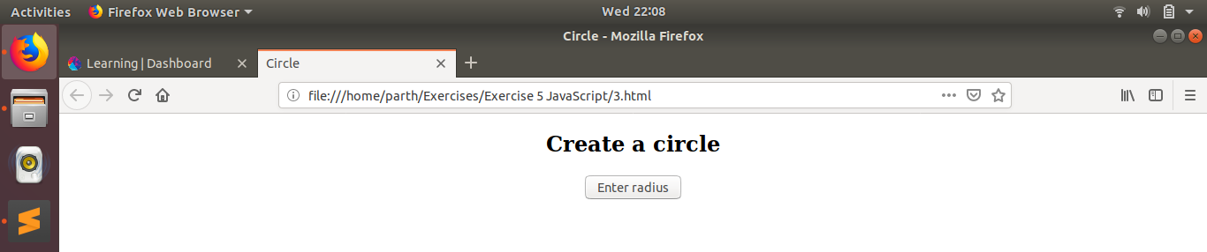
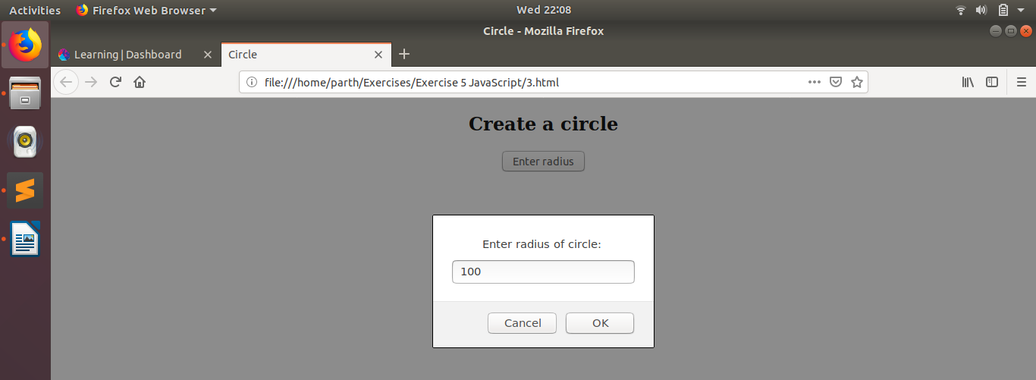
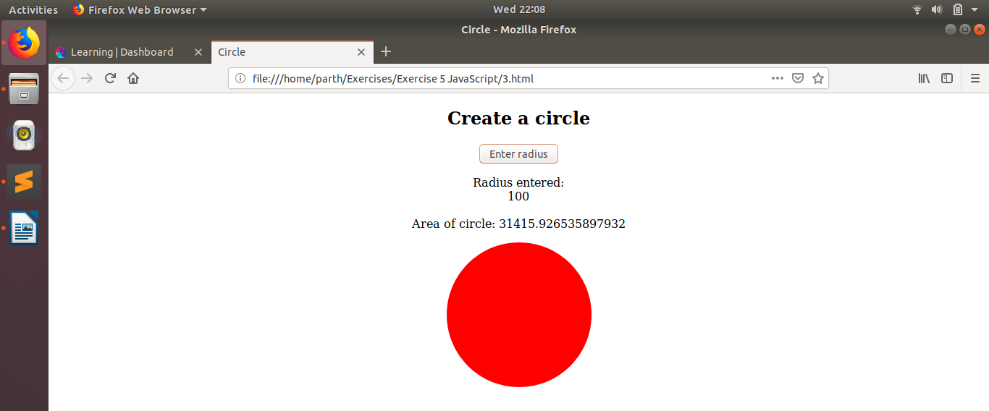

Q4. Copy information of one object to another and log it to console.
A4. 4.html
<!DOCTYPE html>
<html>
<head>
<title>Shallow and Deep Copy</title>
<meta charset="utf-8">
</head>

<body>
<script src = '4.js'></script>
</body>

</html>

4.js
var obj = {a: 1, b: 2};
console.log('obj', obj);

var deepCopy = JSON.parse(JSON.stringify(obj));
console.log('deepCopy', deepCopy);

var shallowCopy = obj;
console.log('shallowCopy', shallowCopy);

obj.a = 3;
console.log('Value changed');
console.log('obj', obj);
console.log('deepCopy', deepCopy);
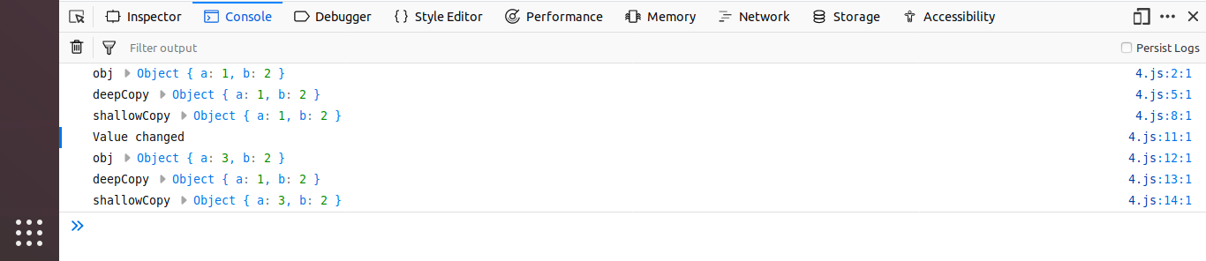
console.log('shallowCopy', shallowCopy);

Q5. Create a list of objects of Employee with info as follow :
- Name, age, salary ,DOB
- filter all employees with salary greater than 5000
- group employee on the basis of their age
- fetch employees with salary less than 1000 and age greater than 20. Then give them an increment 5 times their salary
A5. 5.html
<html>
<head>
<title>Employee</title>
<meta charset="utf-8">
</head>
<body>
<script type="text/javascript" src = '5.js'></script>
</body>
</html>

5.js
employees = [{
name: 'ABC',
age: 35,
salary: 500,
dob: '01.01.1980'
},

{
name: 'DEF',
age: 20,
salary: 10000,
dob: '02.02.1995'

},

{
name: 'GHI',
age: 30,
salary: 100,
dob: '03.03.1985'
},

{
name: 'JKL',
age: 25,
salary: 6000,
dob: '04.04.1990'
}]

console.log(employees);

salGreaterThan5000();

groupByAge();

filterBySalAndAge();

function salGreaterThan5000(){
newArr = []
for(var i = 0; i < employees.length; i++){
if(employees[i].salary > 5000){
newArr.push(employees[i]);
}
}
console.log(newArr);
}

function groupByAge() {
groups = {}
interval_range = 10;

for(var i = 0; i < employees.length; i++){
max_range = Math.floor(employees[i].age / interval_range) * interval_range;
range = max_range.toString() + '-' + (max_range + interval_range - 1).toString();
if(range in groups){
groups[range].push(employees[i]);
}

else{
groups[range] = [employees[i]];
}
}
console.log(groups);
}

function filterBySalAndAge(){
newArr = []
for(var i = 0; i < employees.length; i++){
if(employees[i].salary < 1000 && employees[i].age > 20){
employees[i].salary *= 5;
newArr.push(employees[i])
}
}
console.log(newArr);



